STM32 Automotive ADAS & Active Safety ECU
Circuit Diagrams, Schematics, Block Diagrams & Firmware Flowcharts
GitHub documentation package | Prepared from the supplied Gemini project conversations

1. Project Overview
This document consolidates the design documentation for an STM32 ARM Cortex-M automotive Advanced Driver Assistance System (ADAS) and active-safety ECU prototype. The system combines ultrasonic proximity sensing, dual infrared lane-boundary sensing, interrupt-driven ambient-light detection, PWM audio warnings, a headlight/status output, and a 128 × 64 SSD1306 I2C OLED telemetry interface.
The diagrams are intended for repository documentation and system communication. They express the pin assignments and logical signal paths described in the supplied project material. Before physically wiring hardware, verify the exact board variant, sensor supply requirements, logic-level compatibility, grounding, and actuator driver stages.

2. Design Summary
Subsystem | Implementation | Purpose
Proximity warning | HC-SR04; TRIG PA0; ECHO PA1; PWM buzzer PA8 | Distance measurement and collision-risk audio alert
Lane monitoring | Left IR PA2; right IR PA3 | Lane-boundary tracking and departure warning
Automatic lighting | LDR threshold output on EXTI PA4; PC13 active LOW | Asynchronous low-light response and headlight/status indication
Telemetry | SSD1306 128 × 64 OLED; I2C PB6/PB7; address 0x3C | Live distance, lane, light, health and warning display
Firmware platform | Embedded C/C++; Arduino Core for STM32; PlatformIO | Modular firmware development and flashing workflow

3. System Block Diagram
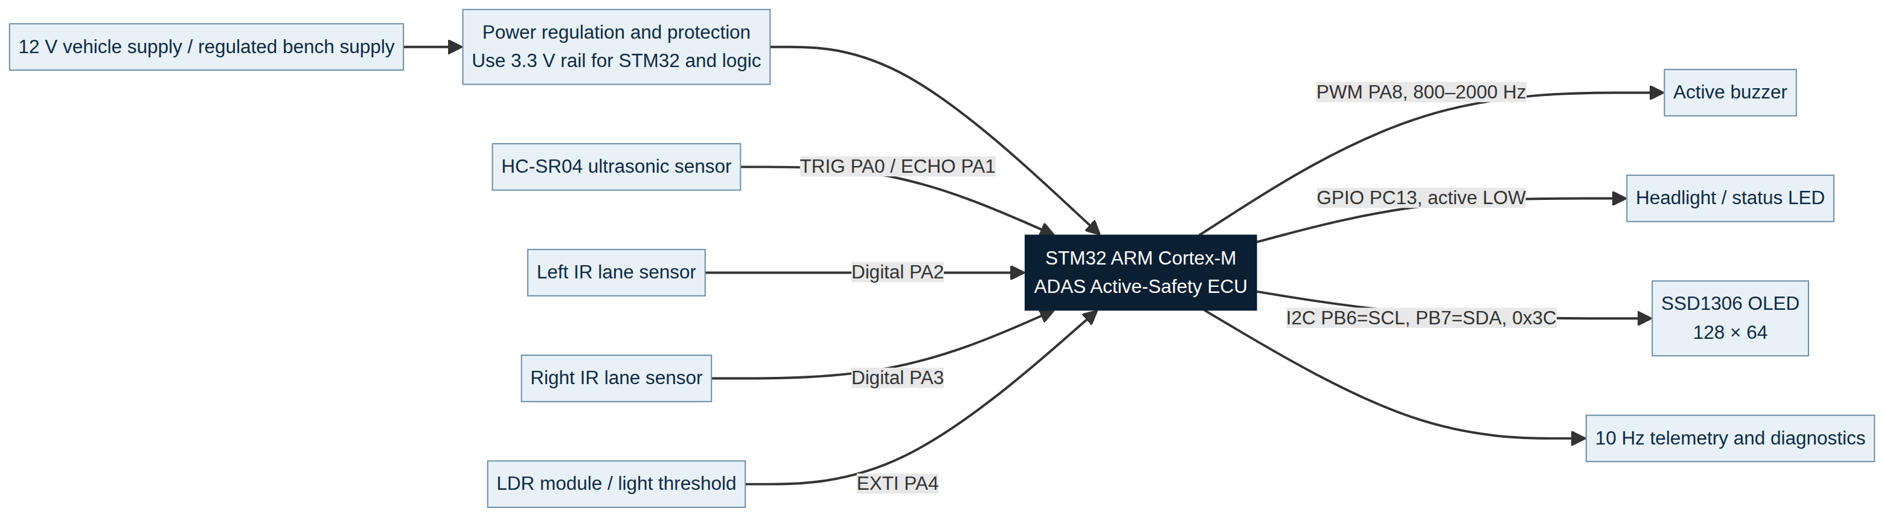
Figure 1. High-level functional architecture of the STM32 ADAS ECU.

4. Pin-Level Wiring Schematic
The following schematic maps the project pinout to the connected sensors, indicators, display, and buzzer. It is a logical wiring reference rather than a PCB layout. The HC-SR04 echo line is explicitly shown through a level-shifting or voltage-divider stage because many HC-SR04 modules drive ECHO at approximately 5 V while STM32 GPIO inputs are commonly 3.3 V tolerant only when the selected pin and board design permit it.
Figure 2. Pin-level logical wiring schematic; starred connections require board-specific electrical verification.

5. Power and Ground Distribution
Use a protected and regulated supply arrangement. The STM32, OLED, IR sensors, and LDR interface should share a stable logic rail and a common ground. Loads such as headlights or a buzzer may require a transistor, MOSFET, or dedicated driver stage; the MCU pin should not be assumed to source the load current directly.
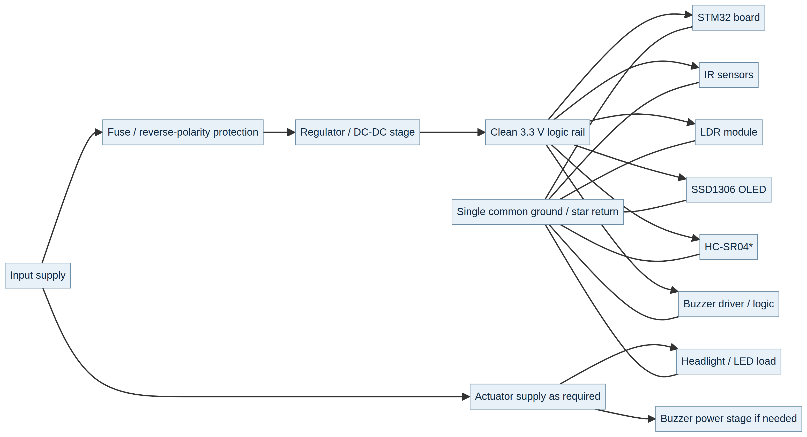
Figure 3. Recommended power, protection, regulation, and common-ground concept.

6. Hardware Pinout Table
Peripheral / component | STM32 pin | Interface | Function
HC-SR04 trigger | PA0 | GPIO output | Ultrasonic trigger pulse
HC-SR04 echo | PA1 | GPIO input / pulse timing | Echo-width measurement
Left IR sensor | PA2 | Digital input | Left lane-boundary tracking
Right IR sensor | PA3 | Digital input | Right lane-boundary tracking
LDR sensor | PA4 | EXTI interrupt | Ambient-light threshold event
Active buzzer | PA8 | PWM / tone output | Variable-pitch proximity warning
Status LED / headlight | PC13 | GPIO output, active LOW | Lighting indicator / output
SSD1306 OLED | PB6 / PB7 | I2C, address 0x3C | Telemetry display

7. Firmware Data Flow
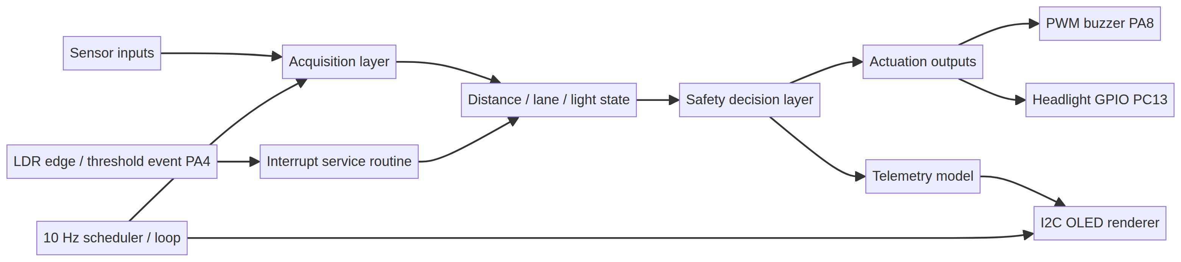
Figure 4. Data path from sensors and interrupt events to decisions, outputs, and telemetry.

8. Main Firmware Flowchart
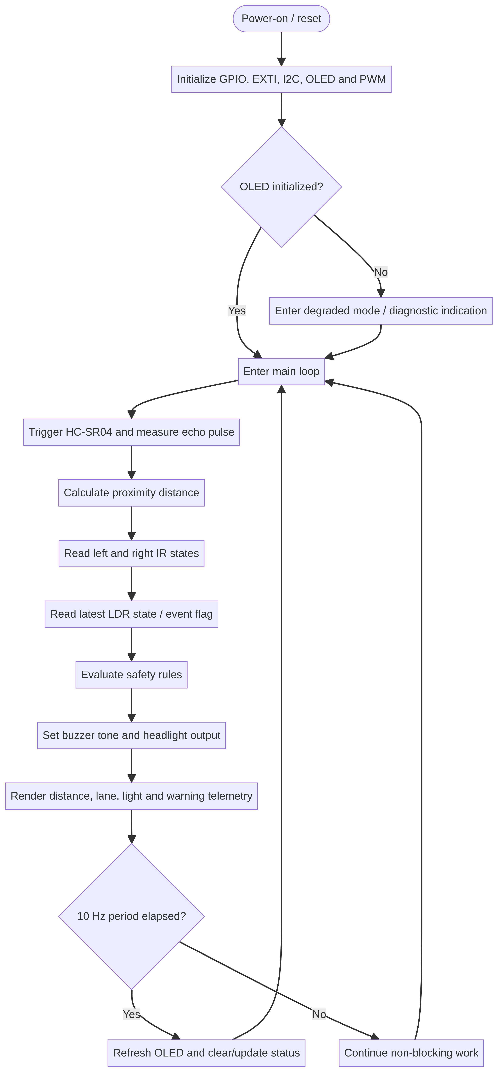
Figure 5. Main-loop and initialization flow for the embedded firmware.

9. Proximity Warning Decision Flow
The project description specifies dynamic buzzer pitch scaling from approximately 800 Hz to 2000 Hz according to collision-risk distance thresholds. The exact threshold values should be kept in one documented configuration section of the firmware so the behavior can be tuned and tested.
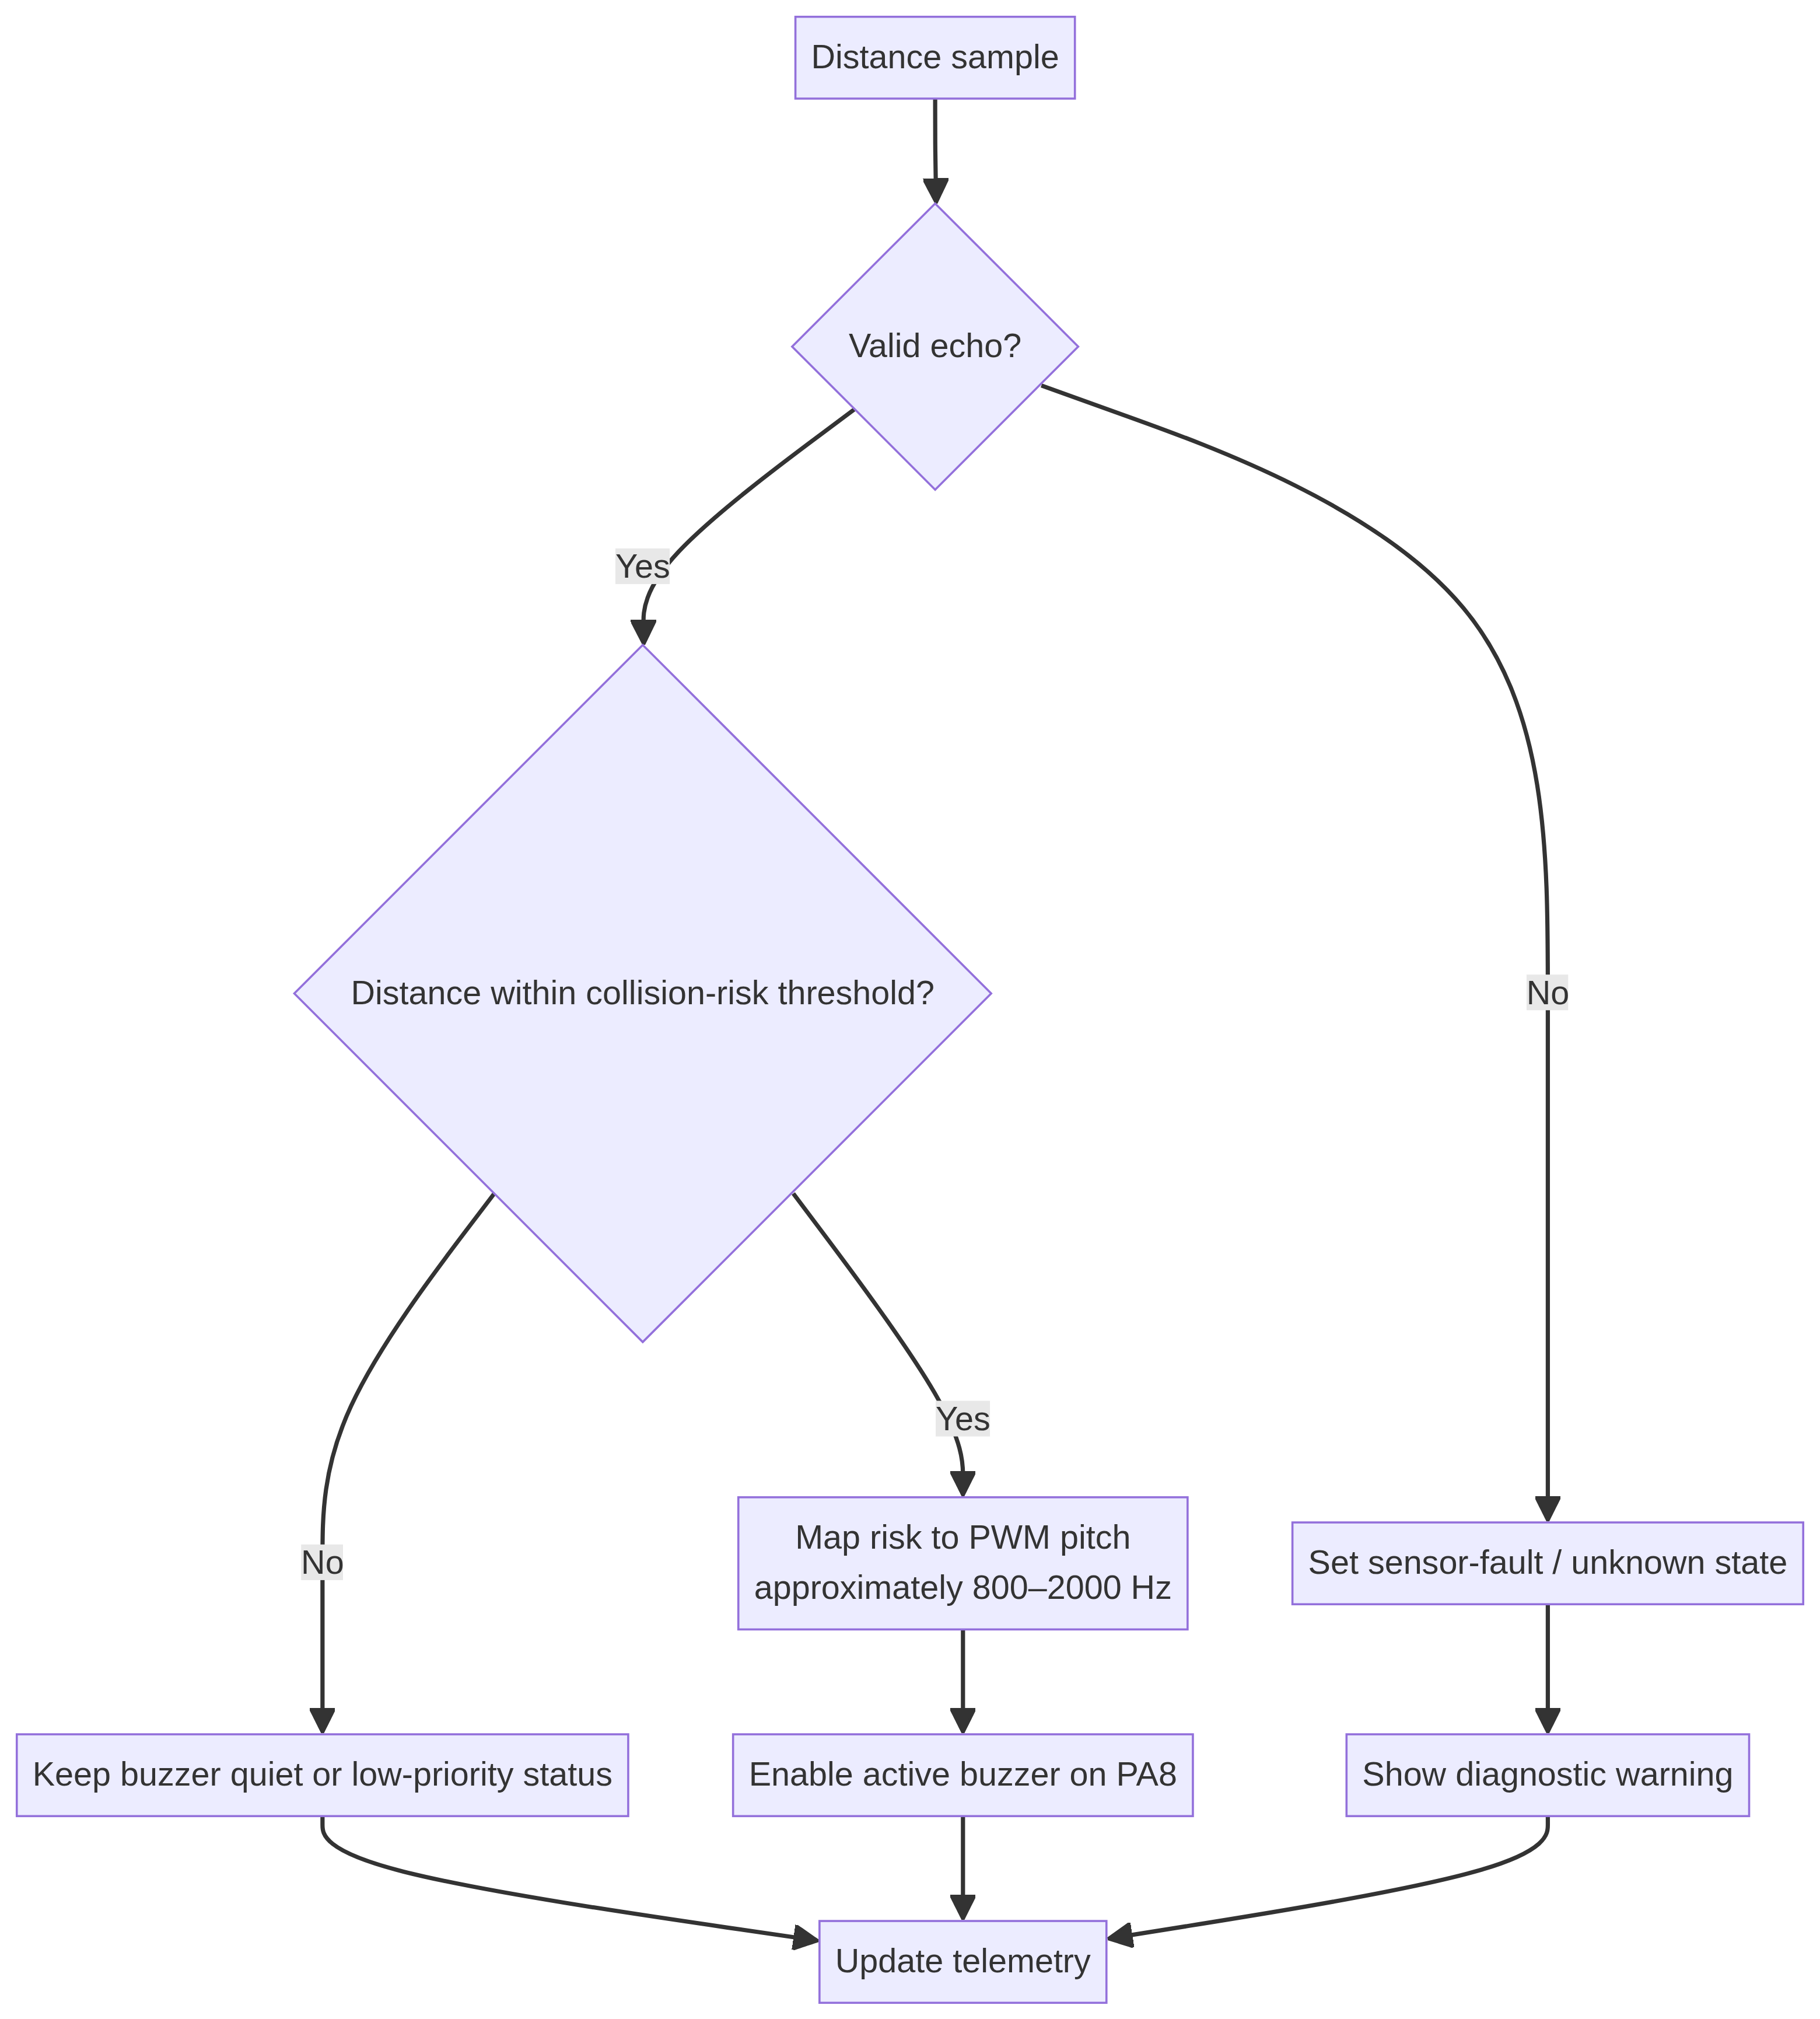
Figure 6. Proximity validity, risk evaluation, buzzer control, and telemetry flow.

10. Lane Monitoring and Automatic Headlight Logic
The LDR path is described as interrupt-driven through EXTI on PA4. The two IR inputs are evaluated as a pair to detect a lane-boundary or lane-departure condition. PC13 is documented as active LOW, so the firmware logic must preserve that polarity in both normal and fault conditions.
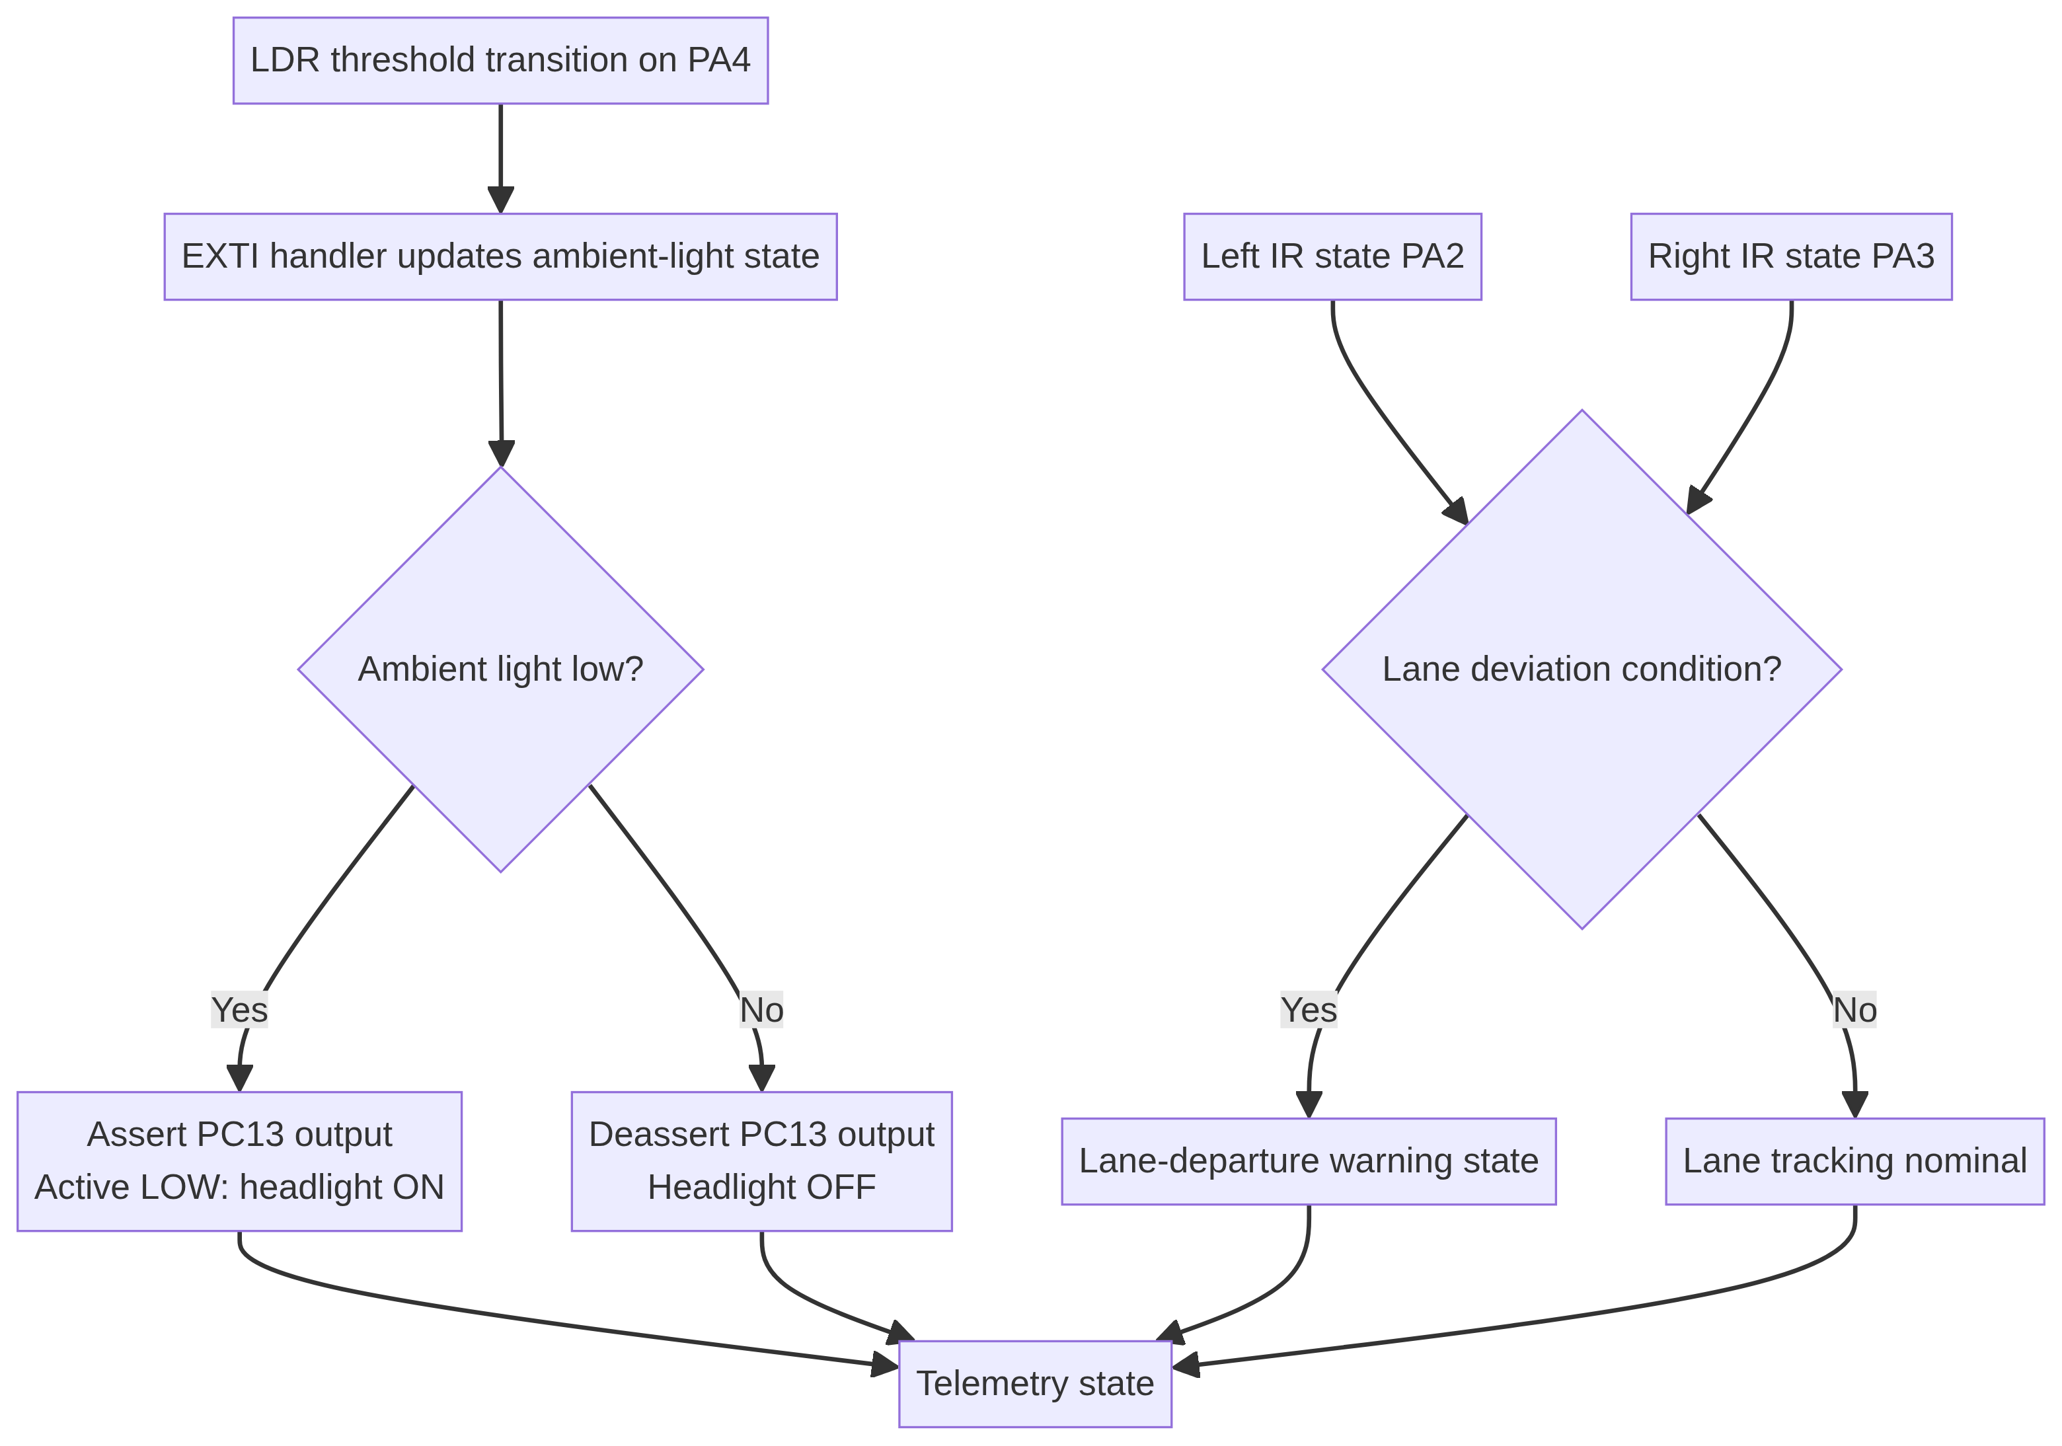
Figure 7. Combined lane-state and ambient-light event logic.

11. Integration Notes and Verification Checklist
- Confirm the exact STM32 board and its voltage-tolerance rules for every input pin.
- Protect the HC-SR04 ECHO signal with an appropriate divider or level shifter when required.
- Connect all modules to a verified common ground and decouple the supply rails near the MCU and display.
- Use a transistor or MOSFET driver for any headlight or buzzer load that exceeds MCU GPIO current limits.
- Check whether the selected LDR module provides a digital threshold output or an analog output; the diagram follows the shared project description of an EXTI-compatible threshold signal on PA4.
- Confirm SSD1306 I2C address 0x3C and scan the bus during bring-up if the display does not initialize.
- Test sensor-fault, out-of-range, and startup cases before presenting the ECU as a safety-related system.

